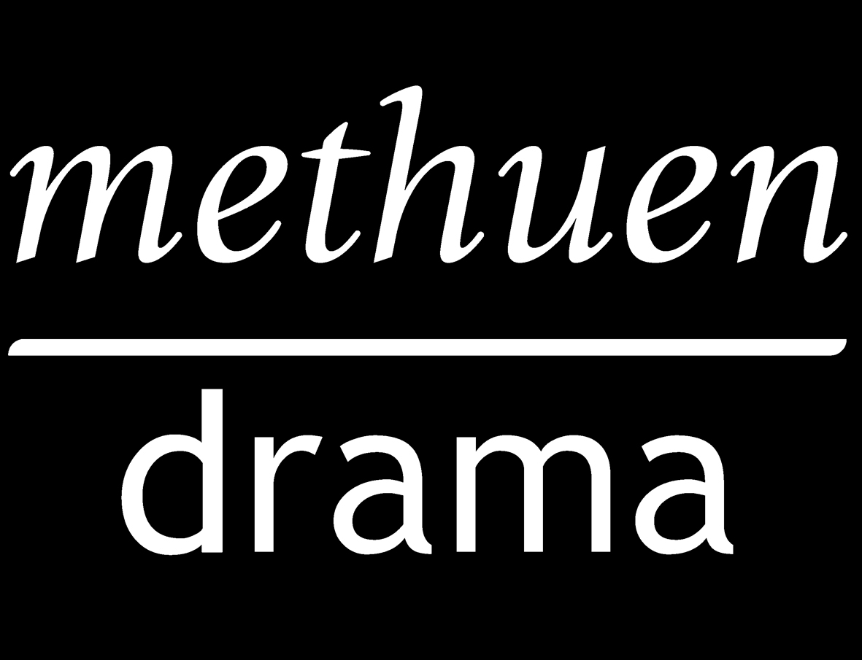
Methuen Drama
Performance Permission Request

Please allow up to 8 weeks for the clearance process

NOTE: To check if we own the performance rights to your play, please check the Performance Rights section of our website before completing this form: www.methuendrama.com

Your details:

Name * ____________________________________________________
Company/University/School * __________________________________

Address * __________________________________________________

___________________________________________________________

Postcode * ___________________________

Contact Tel * _____________________________

Email address * ______________________________________________

Invoice contact name & address (if different from above) ____________

___________________________________________________________

___________________________________________________________

Production details:

Play * _____________________________________________________

Author * ___________________________________________________

Number of performances * _____________________________________

Dates of performances * _______________________________________

Performance Venue * _________________________________________

Ticket price * _______________________________________________

Additional Information ________________________________________

___________________________________________________________

Are you performing the whole play/excerpts? * (please delete as appropriate)

If excerpts, please give details: __________________________________

___________________________________________________________

___________________________________________________________

___________________________________________________________

___________________________________________________________

___________________________________________________________

___________________________________________________________

Are you planning on filming your production? * YES/NO (please delete as appropriate) If yes, please read the Terms and Conditions below

□ Tick here if you would you like to be kept up-to-date with our amateur performance e-newsletter, and provide your email address below:

___________________________________________________________

* These fields are mandatory and incomplete forms will not be processed

Please return your form to:
Email: claire.weatherhead@bloomsbury.com
Post: Claire Weatherhead, Permissions Department, Methuen Drama, 50 Bedford Square, London, WC1B 3DP

Terms and Conditions

Under Copyright Law no public performance or reading of a protected play may be given, either in its entirety or in the form of excerpts, without the prior consent of the owner of the copyright. As agents for the copyright owners we issue licences for performances on payment of a fee. We cannot be held responsible for any loss of revenue resulting from a production being refused.

No changes of any kind may be made to the script without the permission of the author/agent. This includes changing the sex of the characters and cutting out ‘bad’ language. Please provide details of any planned changes with your application form.

If a production is cancelled, a refund can be granted for up to a week before the production is due to start. In this event, it is necessary to return the licence to Methuen Drama.

If there are plans to film a production, this must be for archival use only, with one copy only being retained, and must be cleared with the agent/author at the time of requesting permission.

From time to time it may be necessary for Methuen Drama to withdraw or restrict the amateur performing rights of certain plays. It is therefore in your own interest to apply for permission before committing to a production.

